**5 – CONSTRAINTS** & **KEYS** (BASICS)

CONSTRAINTS ARE CONDITIONS DEFINED ON TABLES, FOR VALID DATA STORAGE.

**TYPES OF CONSTRAINTS**:

1. **NOT NULL** : This column does not allow NULLs. Means, mandatory column
2. **NULL** : This column allow nulls. Means, column value is optional.
3. **UNIQUE** : This column does not allow duplicates. Allows up to 1 null value
4. **PRIMARY KEY** : This column does not allow duplicates, Does not allow null value
5. **FOREIGN KEY** : This is used to **reference** / **link** one table to another table.
6. **CHECK CONSTRAINT** : Used to specify conditions on column values.
7. **DEFAULT CONSTRAINT**: Used to insert a default value to the column.
8. **IDENTITY PROPERTY** : Used to insert automated sequence of values. Ex: 1001, 1002....

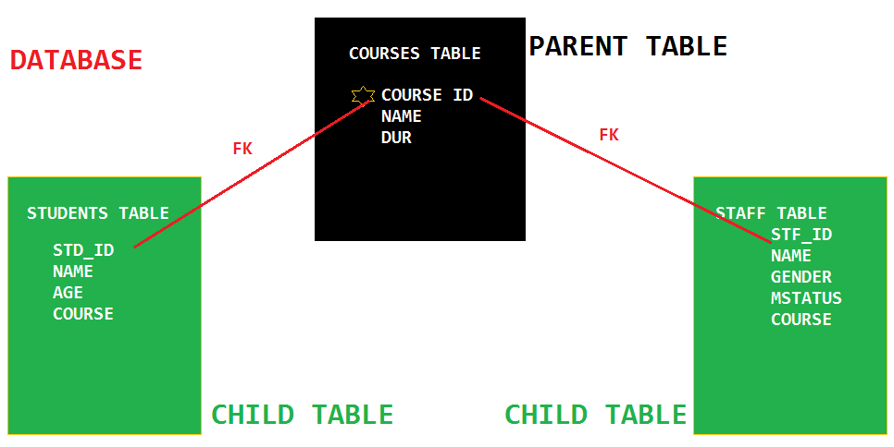

**-- QUERY 1:**

CREATE DATABASE UNIVERSITY_DATABASE

GO

USE UNIVERSITY_DATABASE

GO

**-- QUERY 2:**

CREATE TABLE TBLCOURSES

(

COURSE_ID INT **UNIQUE**,

COURSE_NAME VARCHAR(30) NOT NULL,

COURSE_DUR INT CHECK (COURSE_DUR = 120 OR COURSE_DUR = 180)

)

**-- QUERY 3:**

INSERT INTO TBLCOURSES VALUES (101, 'COMPUTERS', 120)

INSERT INTO TBLCOURSES VALUES (102, 'CIVIL', 180)

INSERT INTO TBLCOURSES VALUES (103, 'ROBOTICS', 120)

**-- QUERY 4:**

SELECT * FROM TBLCOURSES

**-- TESTING UNIQUE KEY:**

INSERT INTO TBLCOURSES VALUES (103, 'AI TECHNOLOGY', 120)

**-- TESTING CHECK CONSTRAINT:**

INSERT INTO TBLCOURSES VALUES (105, 'AI TECHNOLOGY', -120)

**-- TESTING NOT NULL CONSTRAINT:**

INSERT INTO TBLCOURSES VALUES (104, NULL, 120)

**-- QUERY 5:**

CREATE TABLE TBLSTUDENTS

(

STD_ID INT **PRIMARY KEY**,

STD_NAME VARCHAR(30),

STD_AGE TINYINT CHECK (STD_AGE >= 18),

STD_COURSE_ID INT **REFERENCES** tblcourses(course_id)

)

**-- QUERY 6:**

INSERT INTO TBLSTUDENTS VALUES (1001, 'SAI', 34, 101), (1002, 'JON', 34, 101)

INSERT INTO TBLSTUDENTS VALUES (1003, 'JOHNE', 34, 102), (1004, 'JOHNY', 34, 102)

**-- QUERY 7:**

SELECT * FROM TBLSTUDENTS

**-- QUERY 8:**

CREATE TABLE TBLSTAFF

(

STF_ID INT IDENTITY(100001, 1),

STF_NAME VARCHAR(30) NOT NULL,

STF_GENDER CHAR CHECK (STF_GENDER IN ('M','F')) DEFAULT 'F',

STF_COURSE_ID INT REFERENCES tblcourses (course_id)

)

**-- QUERY 9:**

INSERT INTO TBLSTAFF VALUES ('JOHN', 'M', 101), ('JOHNY', 'M', 101)

INSERT INTO TBLSTAFF (STF_NAME, STF_COURSE_ID) VALUES ('JEFF', 101)

**-- QUERY 10:**

SELECT * FROM TBLSTAFF

**--HOW TO VERIFY TABLE TO TABLE RELATIONS IN A DATABASE?**

FROM SSMS > SERVER > DATABASES > RIGHT CLICK DATABASE DIAGRAM > INSTALL DIAGRAM SUPPORT.

RIGHT CLICK DATABASE DIAGRAM > NEW DIAGRAM > SELECT REQUIRED TABLES > OK.